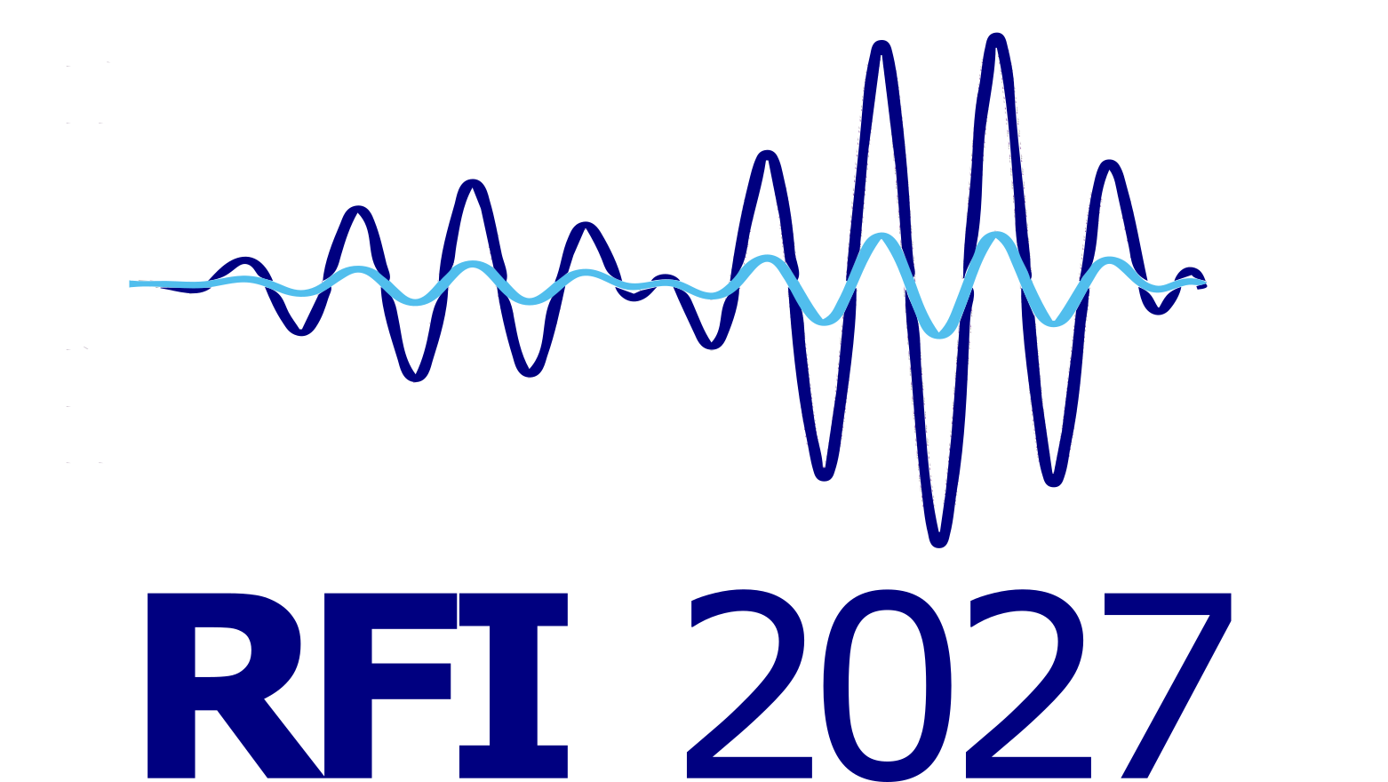
RFI 2027 Abstract Template
May 10-14, 2027 | ESA/ESTEC, Noordwijk, The Netherlands
Submission format: Abstracts should be 1-2 pages. Page 1 should contain the title, authors, affiliations, and abstract text. Page 2 is optional and may contain figures, graphics, or preliminary results. The option to submit a full paper after the conference is currently under discussion. Please delete these instructions before submission.
[Abstract Title]
[Author One]1, [Author Two]2, [Author Three]1
1 [Affiliation, City, Country] | 2 [Affiliation, City, Country]
Presenting author: [Name, email@example.org]

Abstract
[Replace this text with the abstract. Briefly describe the motivation, methods, main results, and significance of the work. Abstracts may address radio frequency interference detection, characterization, mitigation, spectrum management, regulatory processes, monitoring systems, machine learning and AI methods, signal processing, or related spectrum coexistence topics.]
[Keep the main abstract on the first page. If preliminary results, graphics, or figures are helpful, use the optional second page. Please keep figures readable and include short captions.]

Keywords
[Keyword 1]; [Keyword 2]; [Keyword 3]; [Keyword 4]

Preferred Presentation Format
[ ] Oral presentation [ ] Poster presentation [ ] Either

Optional Page 2: Graphics / Preliminary Results
[Insert figure, diagram, table, or preliminary result here]
Figure 1. [Short caption describing the figure or preliminary result.]

Optional Notes
[Use this space only if needed to explain the figure or result. Delete this page if not used.]

